IEEE RAS
The IEEE Robotics and Automation Society’s objectives are scientific, literary and educational in character. The Society strives for the advancement of the theory and practice of robotics and automation engineering and science and of the allied arts and sciences, and for the maintenance of high professional standards among its members, all in consonance with the Constitution and Bylaws of the IEEE and with special attention to such aims within the Field of Interest of the Society. Our mission is to provide an environment for students to grow and nurture their talents under the efficient guidance of reputed IEEE and industrial experts. To keep the students updated with the latest trends and technologies and promote their researches and projects worldwide.
Website
https://edu.ieee.org/in-rasvitcc/
Phone
7904193152Phone number is 7904193152
Industry
Non-profit Organization Management
Company size
51-200 employees
92 associated members LinkedIn members who’ve listed IEEE Robotics And Automation Society VIT Chennai Student Chapter as their current workplace on their profile.
Founded
2018
Locations (1)
Primary
Chennai, IN

Posts
-------



IEEE Robotics And Automation Society VIT Chennai Student Chapter1,051 followers2yr • Edited •
Follow
🏆 IEEE YESIST12 2024🏆
It's with great pleasure that we extend our heartfelt congratulations to the 10 exceptional teams who have secured their positions in the Grand Finale of the IEEE YESIST12 2024 INTERNATIONAL HACKATHON which will take place in TUNISIA by submitting via IEEE RAS VIT Chennai Direct entry.
The teams have demonstrated exemplary innovation, determination, and collaborative spirit, standing out among the 5000+ submissions.
The teams were supported and motivated at every step by the team at IEEE RAS led by IEEE YESIST12 Ambassador Shiv Kumar d and the faculty Coordinators Dr. Sucheta M and Dr. Balaji V R. The qualifying teams were also issued certificates as a token of appreciation by IEEE RAS VIT Chennai.
Let's celebrate the remarkable accomplishments of each team
1. Scrappy Kats:
- Lead: Aansh Sahni (22BCE1429)
- Members: P. Abbas Khan (22BCE5004), Mohit Anand P (22BCE1049)
2. Eco Chain Innovators:
- Faculty Mentor: Dr. Karthik
- Team Lead: Thirumurugan (22BEC1473)
- Team Member: Aditi Mishra (22BCE5240)
3. ECOGROW:
- Faculty Mentor: Dr. Premanand S
- Team Lead: Vidushi Agnihotri (22BLC1387)
- Team Members: Aditya Kumar Jha (22BEC1074), Shikhar Burman (22BLC1335), Sakshi Biyani (22BLC1385)
4. Team Trailblazers:
- Team Lead: Emir Husain (22BCE1184)
- Team Members: Om Aditya (22BCE1142), Shreyas Mohanty (22BCE1335), Saumya Gupta (22BCE1293)
5. Neophytic Techies:
- Team Lead: Vignesh Prabhu S (22BMH1086)
- Team Members: Hariharan K (22BMH1052), Naveen N G (22BMH1121), Sivarish Kosalram M B (22BMH1013)
6. Tech Quad:
- Faculty Mentor: Dr. Yogeeshwar S
- Team Lead: Jeswanth S (23BCE1424)
- Team Members: Surjith Khannan R (23BCE1405), Lohita Lakshmi L.S. (23BCE1178), G Vishnu Swaroop (23BCE1129)
7. App Crafters:
- Faculty Mentor: Dr. Usha Devi T
- Team Lead: Lohithaa K M (22BCE1311)
- Team Members: Sanjana Sudarsan (22BCE5000), Swetha Sriram (22BCE5032)
8. Pregathi:
- Faculty Mentor: Dr. Sakthivel V
- Team Lead: A Harsha Kumar (22BCE1728)
- Members: N Saran (22BCE1592), Disha Daniel (23BEE1016)
9. GenLearn:
- Faculty Mentor: Dr. Vijay Kumar
- Lead: Rudresh Pandey (22BCE1182)
- Members: Shashwat Mishra (22BCE1853), Aditya Mukati (22BCE1310), Yash Rathi (22BCE1892)
10. Wemace:
- Faculty Mentor: Dr. Kumar R
- Team Lead: Venkatesan M (22BAI1259)
- Team Members: TVL Bharathwaj (22BAI1349), Rahul Ashok (22BAI1082), Pritham Devaprasad (22BAI1070)
Congratulations to all the qualified teams!
hashtag#IEEERASVITChennai hashtag#VITChennai hashtag#IEEEYESIST12 hashtag#Hackathon2024 hashtag#Innovation hashtag#Teamwork hashtag#StudentAchievement hashtag#TechCompetition hashtag#IEEE hashtag#Engineering hashtag#Technology
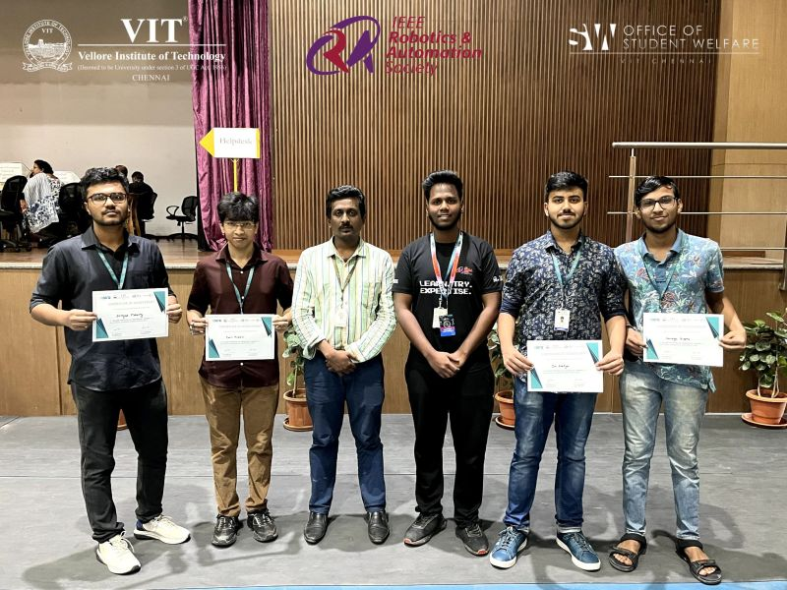
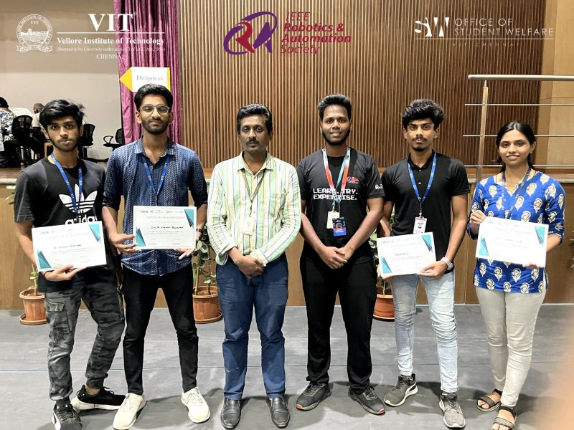
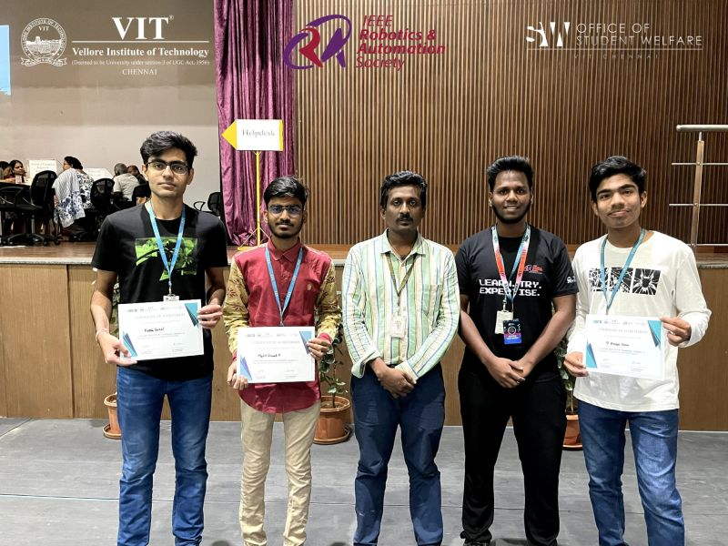
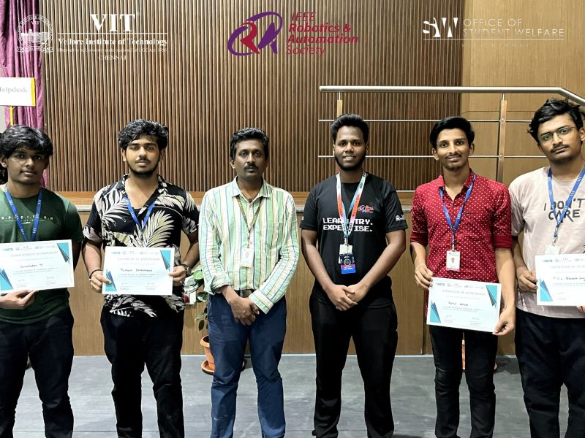
+4
Activate to view larger image,
- 36
Like
Comment
Repost
Send
Feed post number 2

IEEE Robotics And Automation Society VIT Chennai Student Chapter1,051 followers2yr •
Follow
🌟 Beyond Basics: An ESP32 Workshop 🌟
We had an incredible time at the "Beyond Basics: An ESP32 Workshop" held on 27th and 28th Feb 2024 at VIT Chennai! 🚀✨
Participants embarked on an enlightening journey into Embedded Systems Programming and IoT Integration. From exploring the intricacies of microcontrollers and real-time operating systems to mastering the art of connecting ESP with IoT Dashboards, the workshop was packed with valuable insights and hands-on experiences.
Key Highlights:
🔧 In-depth sessions on microcontrollers and real-time applications of ESP32 and ESP8266 Boards
📡 Seamless IoT integration with sensors, actuators, and communication protocols
🤝 Networking with fellow enthusiasts in robotics, automation, and IoT
We taught 70+ members the basics of ESP32 boards and undertook various hands on projects for their in-depth understanding!
The event owes its success to the amazing team and their dedication.
Huge thanks to Kartik Goyal, Lakshminaarayanan V S, Shiv Kumar d, Shaivya Agrawal, Jyotsna Prasanth, Jesher Joshua, Vedansh Kumar, Poorna Swaroop M for their dedication and hardwork !!
A big shoutout to IoTHINC VIT Chennai for co-organizing this fantastic event with us! 🙌
Stay tuned for more exciting workshops and events. Together, we’re building the future of embedded systems and IoT!
hashtag#EmbeddedSystems hashtag#IoT hashtag#ESP32 hashtag#Workshop hashtag#TechCommunity hashtag#Innovation hashtag#Networking hashtag#VITChennai hashtag#IoThincClub hashtag#IEEEStudentChapter hashtag#TechEvents hashtag#IEEERAS hashtag#IEEERASVITChennai
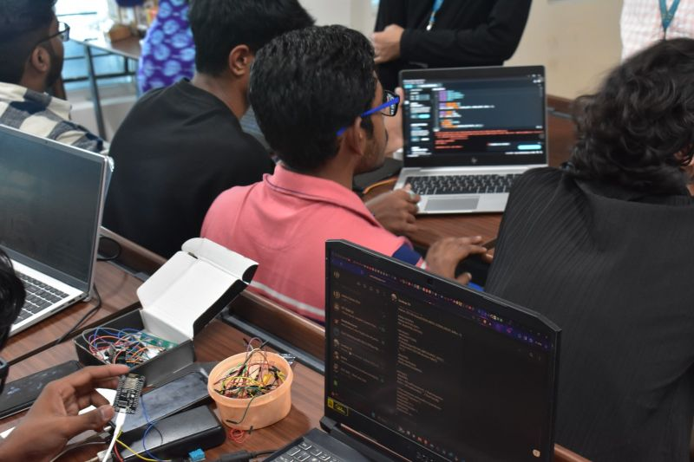
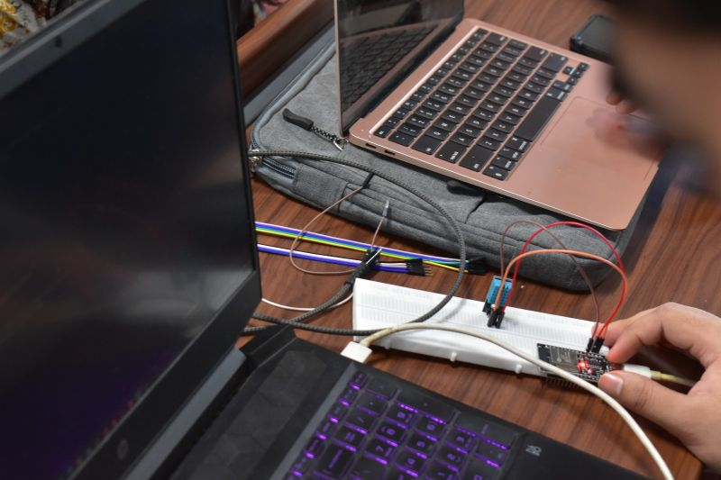
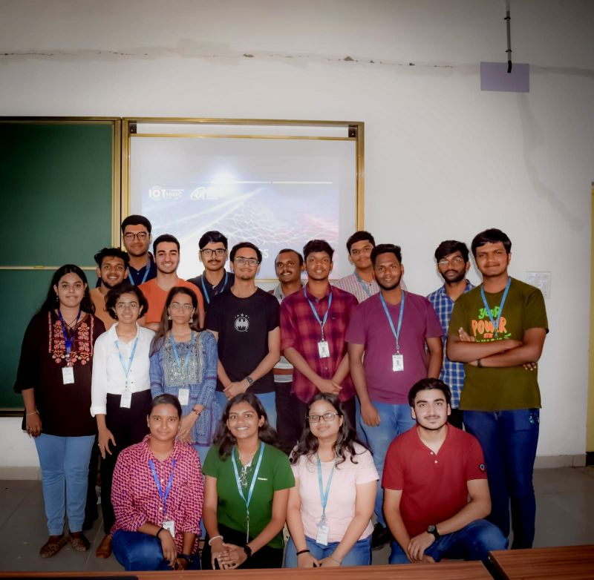
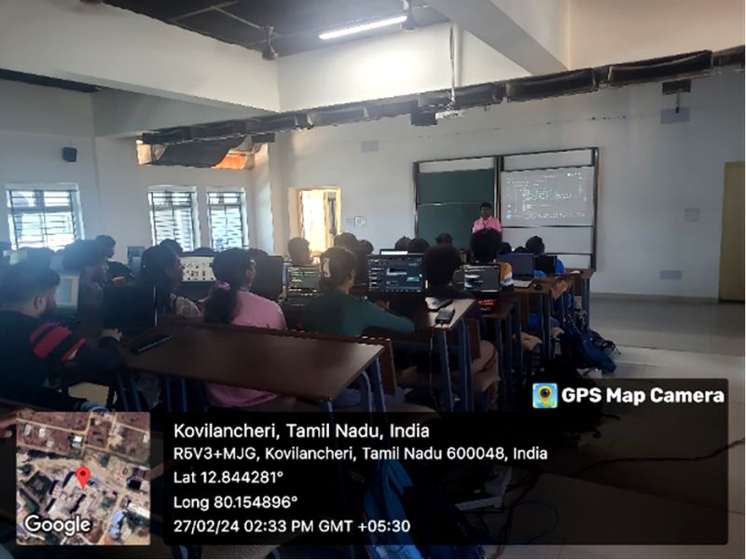
+1
Activate to view larger image,
- 17

  - 1 repost
Like
Comment
Repost
Send
Feed post number 3

IEEE Robotics And Automation Society VIT Chennai Student Chapter1,051 followers2yr •
Follow
🚀 Post-Event Highlights: Data Dash at VIT Chennai! 🚀
On January 22nd, 2024, we hosted an incredible event - Data Dash! 🌟
The day was a fantastic blend of learning and competition. Here’s a recap of the eventful day:
🔍 Introduction to Machine Learning: Attendees kicked off the day with an insightful session on the basics of Machine Learning. From understanding algorithms to practical applications, the session laid a strong foundation for all participants.
💾 Big Data Handling: The next segment delved into the intricacies of handling Big Data. Participants learned about data processing, storage solutions, and efficient data management techniques, equipping them with skills crucial for today’s data-driven world.
🏆 Kaggle Competition: The highlight of the day was the Kaggle competition. Participants formed teams to tackle real-world data problems, applying their newly acquired knowledge in a competitive and collaborative environment. The creativity and problem-solving skills displayed were truly inspiring.
A huge thank you to all our enthusiastic participants for their active engagement and to our dedicated organizing team for their hard work. Your energy and passion for data science made Data Dash an unforgettable experience.
Huge shoutout to our amazing organizing team: Derrick Richard, Sukesh S, Sudeesh M, Afzal Ahmed and our very amazing board members Jesher Joshua, Shiv Kumar d, Kartik Goyal and Rithvika Tiruveedhula!
We’re excited to see how our participants will apply their skills in future projects and competitions. Here’s to many more learning adventures and breakthroughs ahead! 💡🤖📊
hashtag#DataDash hashtag#MachineLearning hashtag#BigData hashtag#KaggleCompetition hashtag#VITChennai hashtag#IEEE hashtag#IEEEStudentChapter hashtag#TechEvents hashtag#DataScience hashtag#LearningJourney hashtag#Innovation hashtag#Collaboration
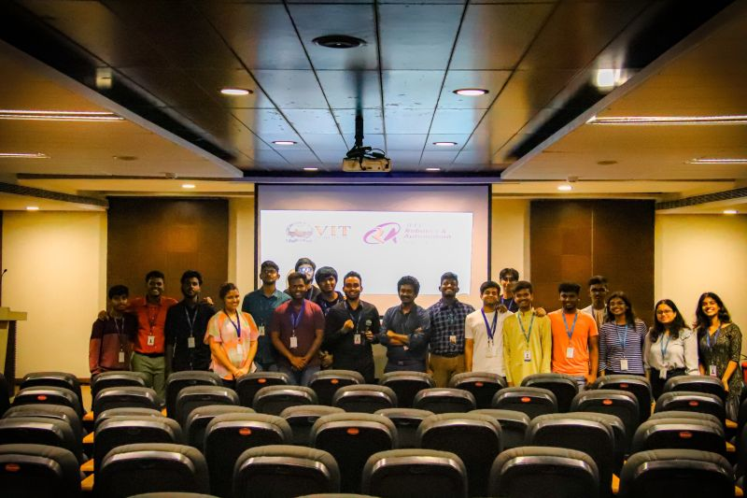
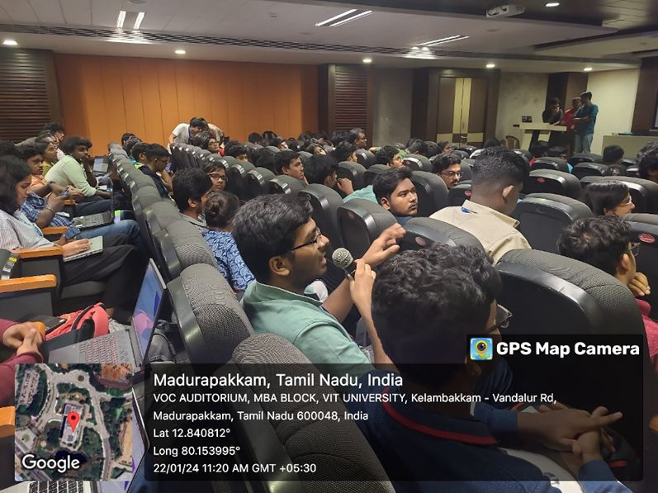
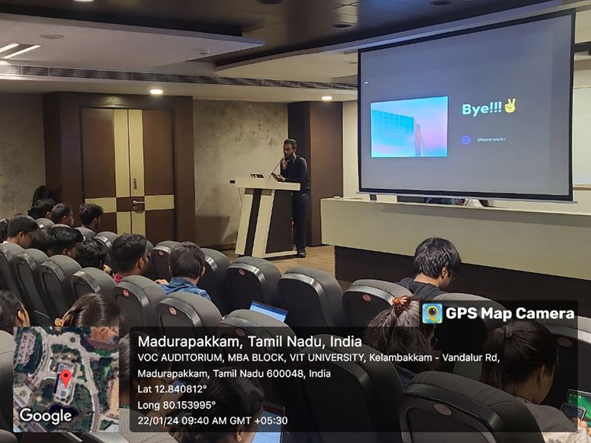
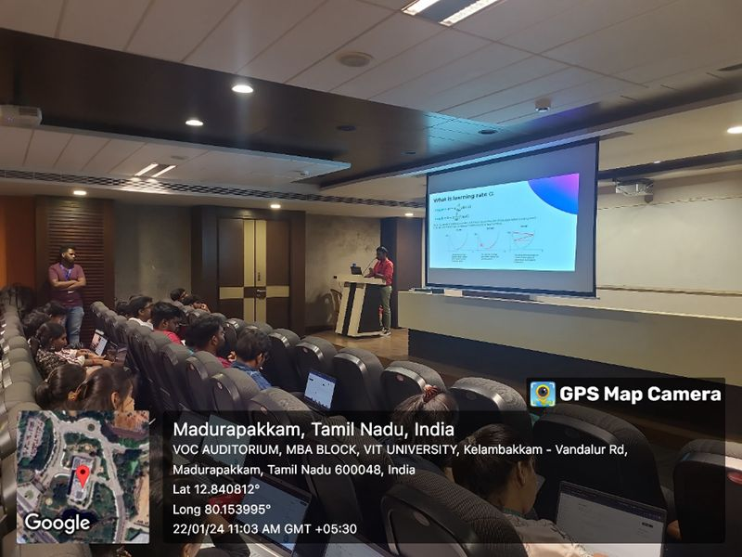
Activate to view larger image,
- 18
Like
Comment
Repost
Send
Feed post number 4

IEEE Robotics And Automation Society VIT Chennai Student Chapter1,051 followers2yr •
Follow
🔧🔋 Arduino 101 Event Recap! 🔋🔧
We had an electrifying experience at the "Arduino 101" workshop hosted by the IEEE RAS Student Chapter of VIT Chennai on December 28th, 2023. The virtual event, held on Google Meet, brought together tech enthusiasts eager to explore the fascinating world of Arduino.
Participants, equipped with their PCs/laptops and Tinkercad software, dived deep into the essentials of Arduino. Lakshminaarayanan V S, SAI ESWARA M and Sanjana PRK, guided the session, sharing their expertise and inspiring attendees with real-world applications and innovative projects.
This workshop was not just an educational experience but a chance to ignite curiosity, expand skill sets, and connect with a community of like-minded individuals passionate about technology and innovation.
With more that 200+ participants the event concluded with a huge success!
Huge shoutout to the organizers and the presenters' exceptional guidance and to everyone who participated for making this event a tremendous success.
hashtag#Arduino101 hashtag#IEEE hashtag#VITChennai hashtag#IEEERAS hashtag#TechLearning hashtag#Innovation hashtag#HandsOn hashtag#TechCommunity hashtag#VirtualWorkshop
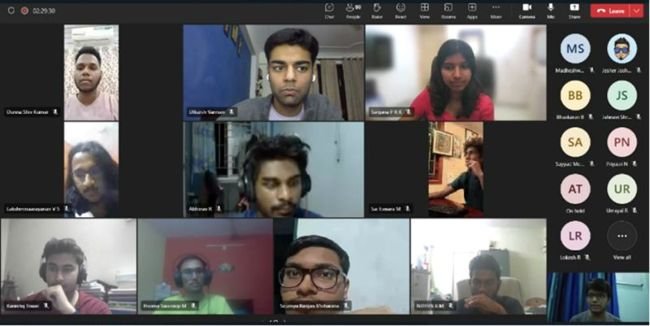
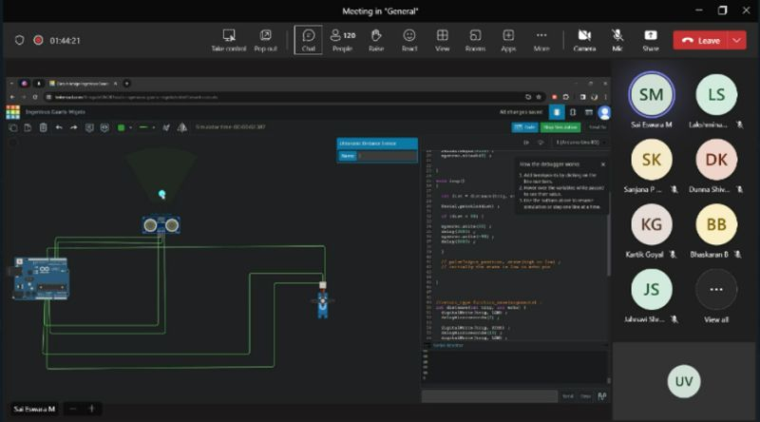
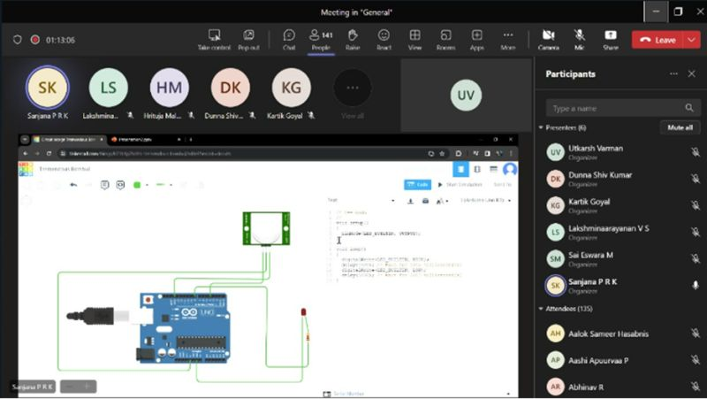
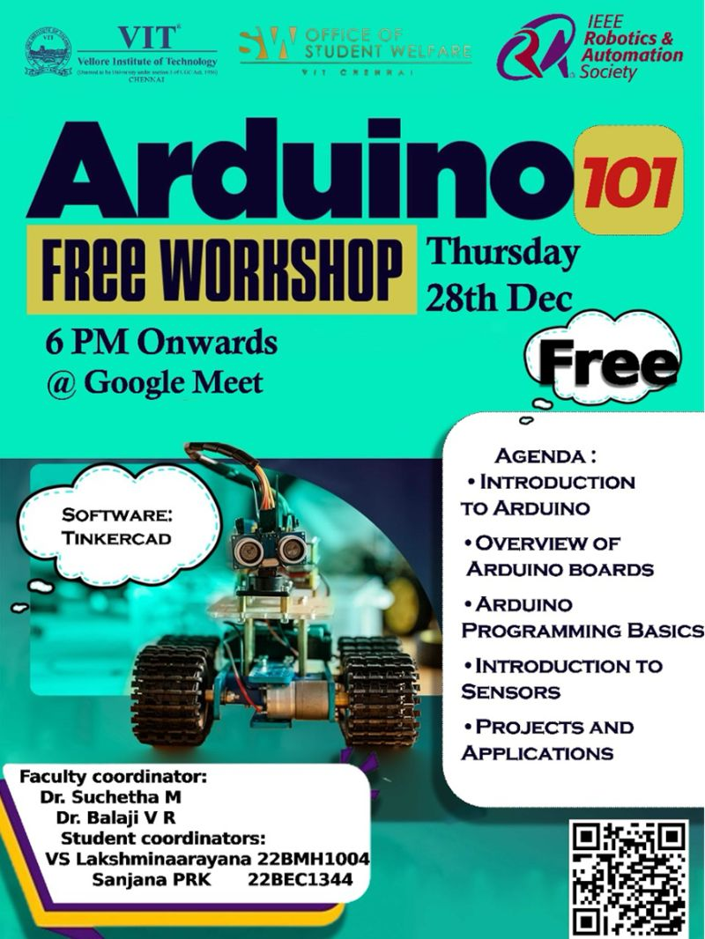
Activate to view larger image,
- 19

  - 1 repost
Like
Comment
Repost
Send
Feed post number 5

IEEE Robotics And Automation Society VIT Chennai Student Chapter1,051 followers2yr •
Follow
🔍🌐 Deep Dive into IEEE Event Recap! 🌐🔍
We had an inspiring and interactive session on 1st November, 2023 at Kasturba Auditorium, VIT CHENNAI with Abdul Halik M I, Secretary of IEEE Madras Young Professionals and MD Chair. Abdul sir shared his invaluable experiences as an IEEE volunteer and highlighted the numerous perks of being an IEEE and IEEE RAS member.
His motivational insights and stories encouraged all attendees to actively participate in volunteering activities and make the most of their IEEE membership. The session was engaging, informative, and truly inspiring for everyone involved.
Thank you to Abdul Halik M I for his time and expertise, and to all the participants for making this event a success. Special thanks to Shiv Kumar d, Kartik Goyal and our faculty coordinator Dr VR Balaji sir for making it possible!
hashtag#IEEE hashtag#IEEEYoungProfessionals hashtag#IEEEEvents hashtag#VITChennai hashtag#IEEERAS hashtag#Volunteering hashtag#TechCommunity hashtag#Inspiration hashtag#ProfessionalGrowth
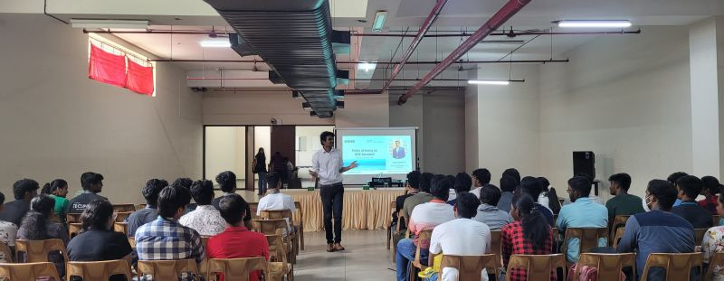
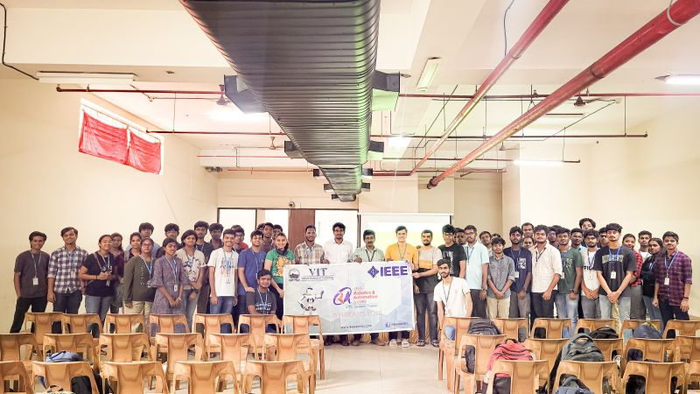
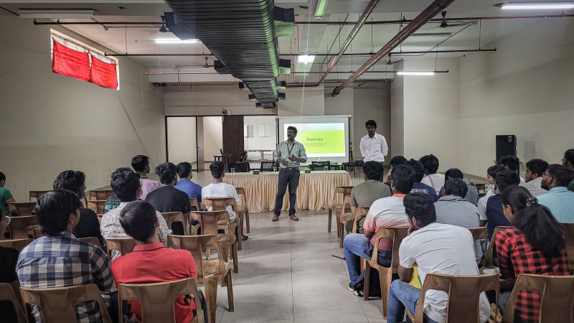
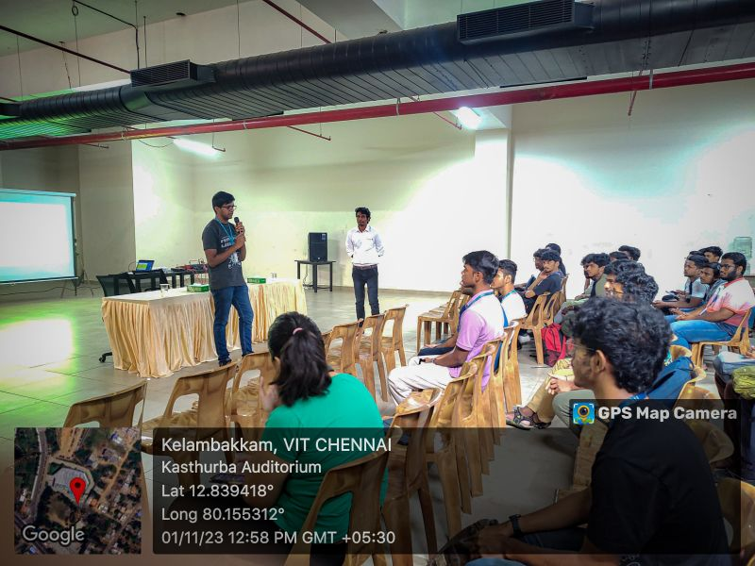
+1
Activate to view larger image,
- 6
Like
Comment
Repost
Send
Feed post number 6

IEEE Robotics And Automation Society VIT Chennai Student Chapter1,051 followers2yr •
Follow
🚗🏁 AWS DeepRacer Event Recap! 🏁🚗
We had an electrifying experience at the AWS DeepRacer event on 5th October 2023 at VIT Chennai! AWS DeepRacer was an exciting autonomous racing challenge where participants trained on how to use reinforcement learning to train model cars to navigate a track. With over 300+ passionate participants, the competition was fierce and thrilling. A special thanks to our generous sponsor C4Scale and Chakravarthy V P for supporting us and contributing!
This event was a major highlight of hashtag#TechnoVIT, VIT Chennai's premier technical fest under hashtag#BandVIT, and showcased the incredible talent and innovation of our community. We are immensely proud of the efforts and enthusiasm of everyone involved.
A huge shoutout to our wonderful team Ashwin Sivakumar, Derrick Richard, Jesher Joshua, Sonaa Rajagopal, Diya Ravishankar, Shiv Kumar d and Kartik Goyal for flawlessly organizing such a remarkable event. Special thanks to our Faculty coordinators Dr V R Balaji and Suchetha M for their constant and unwavering support
Here's to many more tech-driven adventures ahead!
hashtag#AWSDeepRacer hashtag#TECHNOVIT hashtag#VITChennai hashtag#BandVIT hashtag#IEEERAS hashtag#Innovation hashtag#TechFest hashtag#RacingTowardsTheFuture 🚀✨
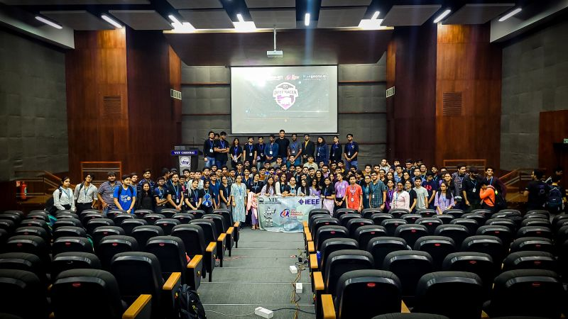
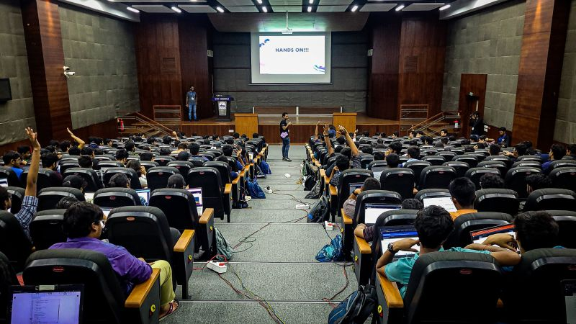
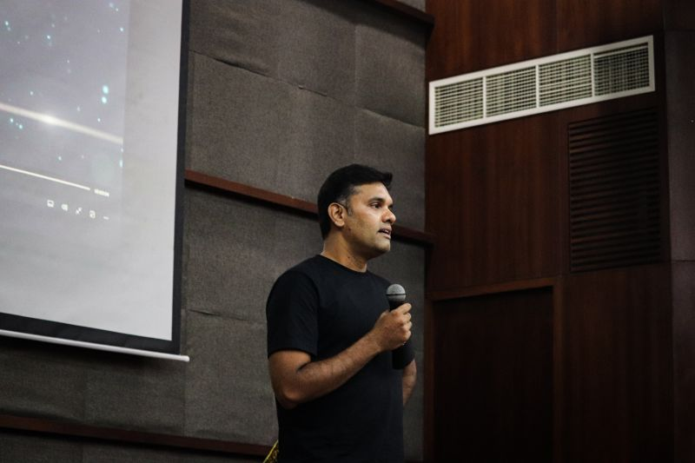
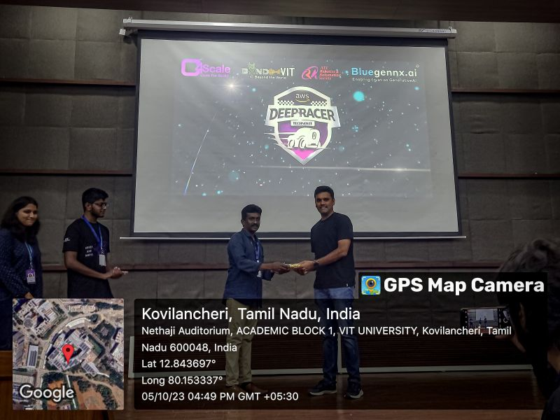
+1
Activate to view larger image,
- 20

  - 3 comments
Like
Comment
Repost
Send
Feed post number 7

IEEE Robotics And Automation Society VIT Chennai Student Chapter1,051 followers6yr • Edited •
Follow
It's the day when workers get together and showcase their strength which indicates how effectively they can struggle to bring in positive reforms for the working class of the society.
Happy May Day!
hashtag#mayday hashtag#leadership
Activate to view larger image,
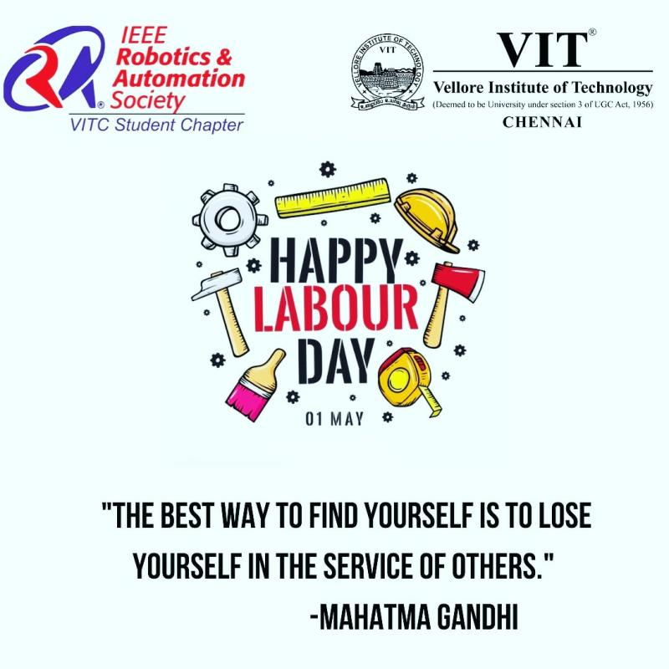
Activate to view larger image,
- 4
Like
Comment
Repost
Send
Feed post number 8

IEEE Robotics And Automation Society VIT Chennai Student Chapter1,051 followers6yr •
Follow
എല്ലാകൂട്ടുകാർക്കും
നന്മ നിറഞ്ഞ ഒരു വിഷു ആശംസിക്കുന്നു
ഒപ്പം സമ്പൽസമൃതിയാർന്ന ഒരു വർഷമാകട്ടെ ഇതെന്ന് പ്രാർത്ഥിക്കുന്നു
Show translation
Activate to view larger image,
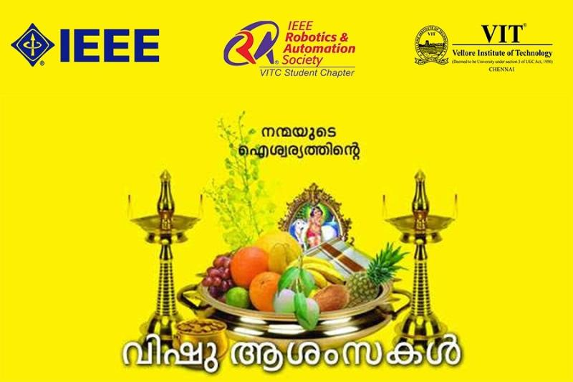
Activate to view larger image,
- 1
Like
Comment
Repost
Send
Feed post number 9

IEEE Robotics And Automation Society VIT Chennai Student Chapter1,051 followers6yr •
Follow
உங்கள் குடும்பமும்
நீங்களும் எல்லா வளமும்
நலமும் பெற வேண்டும்
இனிய தமிழ் புத்தாண்டு வாழ்த்துக்கள்
পুরনো যত হতাশা, দুঃখ, অবসাদ, নতুন বছর সেগুলোকে করুক ধূলিসাৎ। সুখ, আনন্দে মুছে যাক সকল যাতনা।
শুভ পহেলা বৈশাখ
IEEE RAS VIT CHENNAI
hashtag#stay_safe
Show translation
Activate to view larger image,
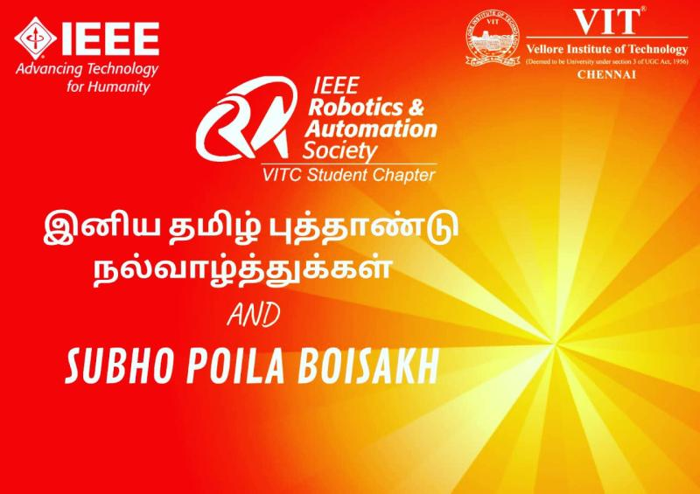
Activate to view larger image,
- 2
Like
Comment
Repost
Send
Feed post number 10

IEEE Robotics And Automation Society VIT Chennai Student Chapter1,051 followers6yr •
Follow
Creativity is thinking up new things.
Innovation is making it happen.
It's just not about picking up the idea.
But a place to showcase it.
Here we give you a platform ISRA 200
Presenting you the Topics of ISRA 2020
We have got it all covered.
hashtag#robotics hashtag#automation hashtag#ieee hashtag#international
EXPLORE ENRICH EVOLVE
Siva Shankar S
Muthuveerappan AL
Nikita Rath
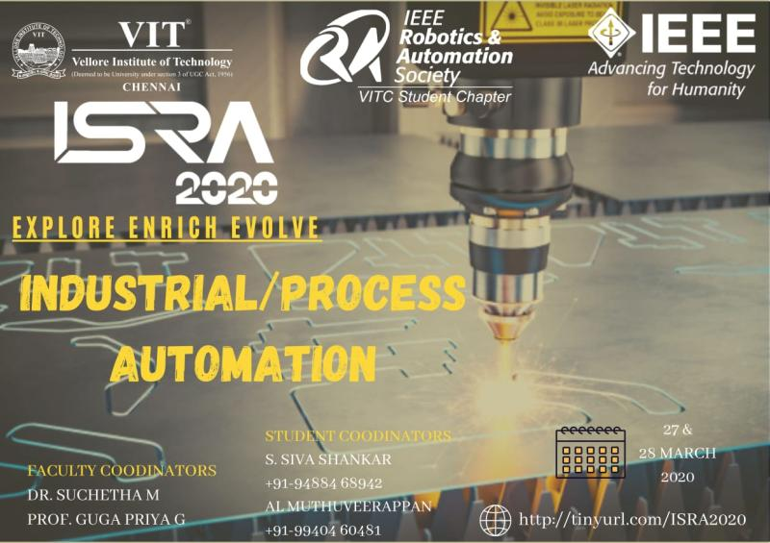
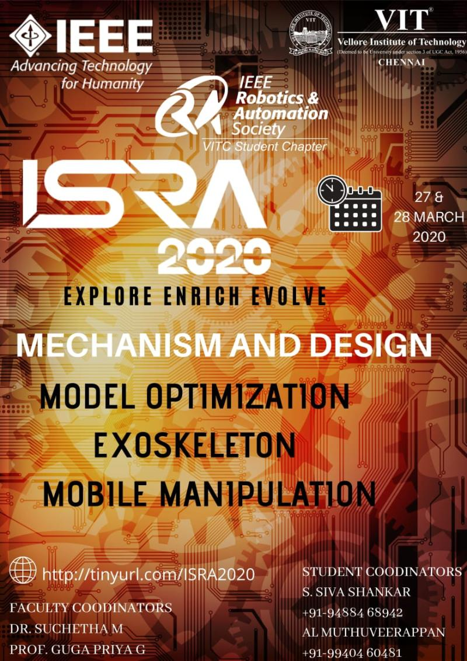
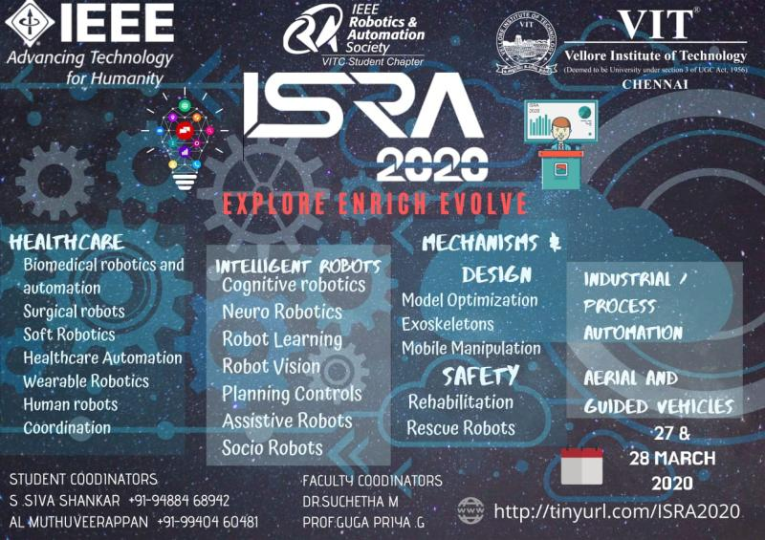
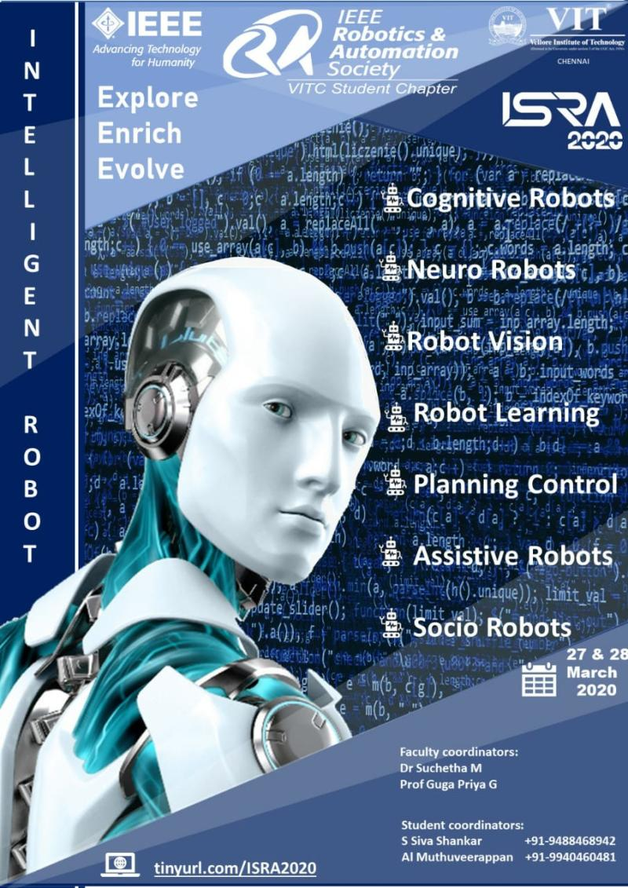
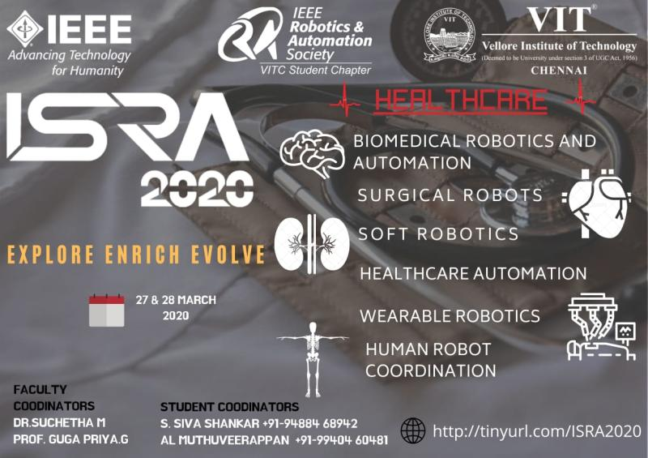
+2
Activate to view larger image,
- 6
Like
Comment
Repost
Send
Feed post number 11

IEEE Robotics And Automation Society VIT Chennai Student Chapter1,051 followers6yr •
Follow
Greetings from ISRA Steering Committee.
We are glad to inform that we are inviting Submissions.
Let's Explore Enrich Evolve
https://lnkd.in/fhkBTTZ
hashtag#symposium hashtag#ras hashtag#ieee hashtag#international hashtag#inviting hashtag#submissions
Activate to view larger image,
